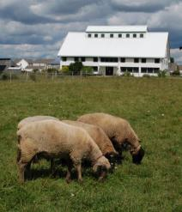
Sheep Adoption Form

Name _________________________
Address _______________________
_______________________
Phone ____________________
E-Mail ___________________
Date _________________

Animal(s) being adopted __________________________

Level 1 $25 Includes a certificate of adoption and an invitation to meet the animals

Level 2 $50 Includes the above plus a photo coaster or magnet clip of your adopted animal

Level 3 $100 Includes the above plus 2 visits with the animals at a time convenient for you and for SC staff

You can help support Shepherd’s Corners mission of connecting people with creation by adopting one of our sheep. Your adoption fees help us feed and care for these animals.
The expenses involved in maintaining healthy, well-adjusted animals are not insignificant.
Adoptions make an excellent gift and are good for one full year.
What better way to say “I care about Shepherd’s Corner and the work they do.”

Contact us at 614-866-4302 for more information.

987 N. Waggoner Rd
Blacklick, OH 43002
www.shepherdscorner.org

